
Lab Program Number: 33 Date: 19th March,2026
Title: Configuring SSH server to allow/deny root login for selected hosts only.

- Open SSH configuration file.
Command:

- Allow login only from a specific IP or name.
Command:
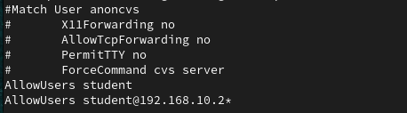
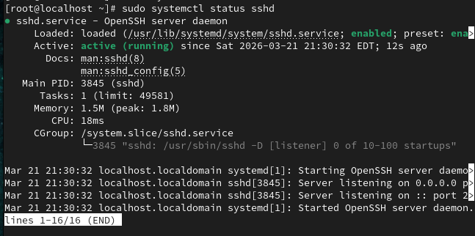
- Deny login from specific hosts/users.
Command:
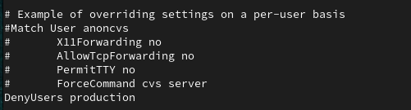

- Restart SSH service
Status:
